PROJECT PROPOSAL

NIHVA TECHNOLOGIES PVT. LTD.
187, G-Block, Thermax chowk, Above Renault Showroom, MIDC
Chinchwad, Pune – 411019.

Customer Name | ITC HYDRABAD
Project Name | TRS PACKING AUTOMATION
Project Location | Guntur
Contact Person Name | Mr. Nitesh K.
Email Id | Nitesh.k@itc.in
Contact Number | +91-9866270686

Contact Person: Mr. Arjun Patil
Mob No.: 8551096333
Email id: automation@nihva.com
Web: http://www.nihva.com

Project Title: TRS PACKING AUTOMATION
Date: 17/7/2018
Dear Sir,

Thank you for the opportunity and trust shown on “NIHVA” your preferred partner for innovative solutions. This has reference to your above mentioned requirements as well as our subsequent communication; please find below our best offer.

A. Requirement:
Packing of chili powder pouches of different sizes. Require process is as below.
Process Flow Chart for Process 1:

Filling Line &
Take Off Conveyor
Filling Line &
Take Off Conveyor

Compression conveyor
Compression conveyor

Check weigher
Check weigher

Flat belt conveyor
Flat belt conveyor

High speed conveyor
Merging conveyor
Flat belt conveyor

Pick & Place m/c,
Case erector & Conveyor

Flat belt conveyor &
Application of carton top cover

Manual application of box cover

BOPP Tapping

Flat belt conveyor for box collection

Product Details : ( for 1 kg chilly bag )
Details
Pack size | 330 x 190 x 55  L x B x H
Pouch Style | Side gazetted Penta seal
Pouches/shipper (nos) | 06 no’s
Kg/shipper | 6 kg
Shipper size | 300 x 190 x 225  L x B x H
Shipper type | 3 ply
No.of machines | 01
Machine output | 80 Pouches/min

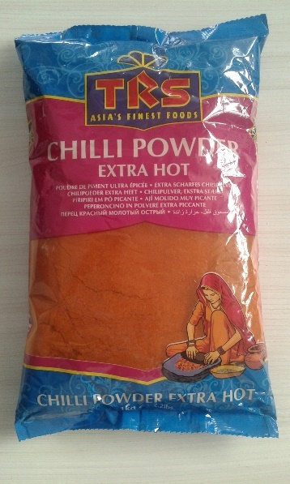

Product Details : ( for 100gms chilly pouch )

Details
Pack size | 190 x 110 x 15  L x B x H
Pouch Style | Side gazetted Penta seal
Pouches/shipper (nos) | 20 nos’
Kg/shipper | 2 kg
Shipper size | 320 x 110 x 180  L x B x H
Shipper type | 3 ply
No.of machines | 01
Machine output | 80pouches/min

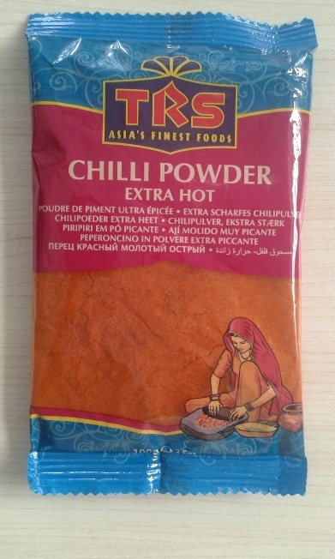

Technical Specifications: - (For 5 kg Tea Bag)
Sr No. | Packaging System Description | QTY
1 | compression Conveyor A |  | 1
 | • Conveyor Width | 350 mm
 | • Conveyor Length | 2050 mm
 | • Construction | MS Powder Coated
 | • Contact Parts | SS304
 | • SKID PLATE | SS304
 | • Motor | Bonfiglioli with Gear
2 | Flat belt conveyor A |  | 1
 | - Conveyor width | 350 mm
 | - Conveyor length | 1062mm
 | - Construction | MS Powder Coated
 | - Contact parts | SS304
 | - Skid plate | SS304
 | - Motor | Bonfiglioli with Gear
3 | compression Conveyor B |  | 1
 | • Conveyor Width | 350 mm
 | • Conveyor Length | 2050 mm
 | • Construction | MS Powder Coated
 | • Contact Parts | SS304
 | • SKID PLATE | SS304
 | • Motor | Bonfiglioli with Gear
4 | Flat belt conveyor A |  | 1
 | Conveyor width | 350 mm
 | Conveyor length | 1362mm
 | Construction | MS Powder Coated
 | Contact parts | SS304
 | Skid plate | SS304
 | Motor | Bonfiglioli with Gear
5 | Flat belt conveyor |  | 1
 | • Conveyor Width | 330 mm
 | • Conveyor Length | 1700 mm
 | • Construction | MS Powder Coated
 | • Contact Parts | SS304
 | • SKID PLATE | SS304
 | • Motor | Bonfiglioli with Gear
6 | Merging conveyor |  | 1
 | • Conveyor Width | 350 mm
 | • Conveyor length | 1000 mm
 | - Construction | MS Powder coated
 | - Contact parts | Ss304
7 | Check Weigher & Rejector Machine |  | 1
 | • Display | Graphic LCD
 | • Maximum weight | 6 kg
 | • Weighing Scale | 0-6 kgs.
 | • Accuracy | is + /- 0.2 kg
 | • Conveyor Belt | Roller Type
 | • Conveyor Belt Width | 350 mm
 | • Speed | 80 pouches/min
 | • Sensor | Load Cell
 | • Material of construction | MS Powder Coated
 | • Rejection Mechanism | Conveyor Stoppage/Pneumatic Pusher Type
 | • Power Consumption | approx. 350 VA
8 | High speed conveyor |  | 1
 | - Conveyor width | 350mm
 | - Conveyor length | 1200
 | - Construction | MS Powder coated
 | - Contact parts | SS304
 | - Skid plate | SS304
 | - Motor | Bonfiglioli with gear
9 | Automatic Carton Erector Machine |  | 1
 | • Production speed | 12 cartons/min
 | • Carton size(mm) | 300 L x 190 W x 225H
 | • Power supply | 110/220V50/60HZ 1Phase 200W
 | • Air Compressing | 6kg/cm³
 | • Adhesive tape width | 48/60/75MM
 | • Machine dimension | L2000xW1900xH1450mm
 | • Machine weight | 450 Kgs
 | • Motor | Bonfiglioli with Gear
10 | Flat belt conveyor |  | 1
 | • Conveyor Width | 330 mm
 | • Conveyor Length | 1700 mm
 | • Construction | MS Powder Coated
 | • Contact Parts | SS304
 | • SKID PLATE | SS304
 | • Motor | Bonfiglioli with Gear
11 | Automatic Carton Sealer (BOPP Tapping) |  | 1
 | • Carton Size | 300 L x 190 W x 225H
 | • Sealing Capacity | About 1000 Standard Case Per Hour
 | • Adhesive Tape Used | BOPP Self Adhesive Tape
 | • Power Sources | 220 V, 50 Hz, 250w
 | • Max Sealing Dimensions { W X H } | 200mm X 225mm
 | •Min. Sealing Dimension { W X H } | 300+-100 mm
 | • Motor | Bonfiglioli with Gear
 |  |  | 1
12 | Flat belt conveyor |  | 1
 | • Conveyor Width | 330 mm
 | • Conveyor Length | 1700 mm
 | • Construction | MS Powder Coated
 | • Contact Parts | SS304
 | • SKID PLATE | SS304
 | • Motor | Bonfiglioli with Gear

Images : -

1. Roller Flattening Conveyor 2. Check weigher & Rejecter Machine


3. Automatic Carton Sealer M/c

Sr no | Description | Qty | Unit | Rate in INR | Net Amount  INR
1 | Compression conveyor | 2 | No | 1,70,000 | 3,40,000
2 | Flat belt conveyor (L 1000) | 1 | No | 65000 | 65000
3 | Flat Belt Conveyor (L800) | 1 | No | 50,000 | 50,000
4 | Flat belt conveyor (L1700) | 1 | No | 95,000 | 95,000
5 | Merging conveyor (L1000) | 1 | No | 65,000 | 65,000
6 | Check Weigher (up to 1kg product) | 2 | No | 5,80,000 | 11,60,000
7 | High Speed Conveyor | 1 | No | 70,000 | 70,000
8 | Carton Erector Machine | 1 | No | 8,50,000 | 8,50,000
9 | Roller Conveyor | 1 | No | 90,000 | 90,000
10 | Pop up units | 2 | No | 90,000 | 180,000
11 | Box tilting & Pouch Feeding Unit | 1 | No | 4,00,000 | 4,00,000
12 | Flat belt conveyor (L 1000) | 2 | No | 65,000 | 1,30,000
13 | Case Taping Machine / BOPP machine | 1 | No | 2,75,000 | 2,75,000
Cost of Project |  | 1 | Set |  | 37,70,000
 |  |  |  | TOTAL | 37,70,000

GST PUNE: 27AAECN0437H1ZM | Amount in Words:  Rupees Thirty-Seven Lacs Seventy Thousand Only
HSN Code: 84289090

E. Drawings Training and warranty

Drawing:

We will issue a full set of drawings for approval within 2 weeks of receiving the confirmed order and finalized design details.

Training:

After installation of the Conveyor system, we will train the Clients personnel in the operation and basic maintenance, including the understanding of the error codes on the control system (if applicable).

Warranty:

- The warranty period is twelve months from the date of installation and commissioning.
- If a defect arises within the warranty period stated, which is attributable to faulty design,
- materials or installation workmanship the product will be repaired at our discretion without charge.

- This guarantee is subject to proper use of the product and assumes that the product is regularly serviced and maintained by skilled personnel in accordance with the operation and maintenance instructions supplied.

- Maintenance & Service Agreement:
We would suggest that you take advantage of a maintenance and service agreement on the NIHVA products, which will guarantee trouble free operation and speed of response in an emergency. Customized proposals are available on request.

We are pleased to inform that we also undertake AMC for all of our

products & for any of your existing facilities.

Maintenance and service aren’t about what you get. They’re about what

you avoid: failures, losses and unplanned interruptions.
- Client Scope:
- Unloading from truck placement on site.

- Exiting/Repair/ Modification/ Refurbishment charges will be extra.

G. Terms and Conditions: -

- Price : Ex. Works Pune

- P & F : 3 % Extra at the time of delivery.

- Freight Notes : Extra as applicable.

- Delivery : Within 10- 12 weeks from date of receipt of
confirmed purchase order, advance payment,
drawing approval.

- Payment Terms : 80% advance along with confirmed purchase
order balance before dispatch.

- Insurance : Extra as applicable.

- GST : As Applicable on total supply value.

- Validity : 15 days from date of quotation.

9.Warranty : 12 months from date of supply.

Please feel free to contact Mr. Arjun Patil on 8551096333 for any further clarification in this concern.

With Best Regards,
Arjun Patil
For NIHVA Technologies Pvt Ltd

